The line graphs below show the production and demand for steel in million tonnes and the number of workers employed in the steel industry in the UK in 2010.

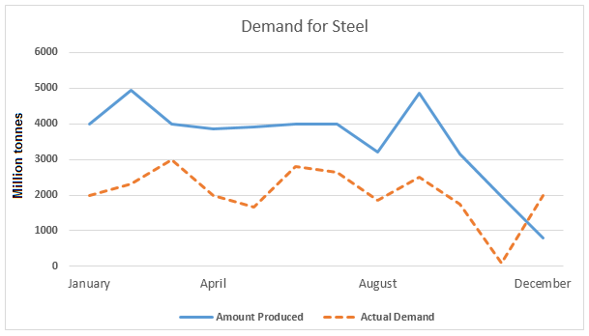

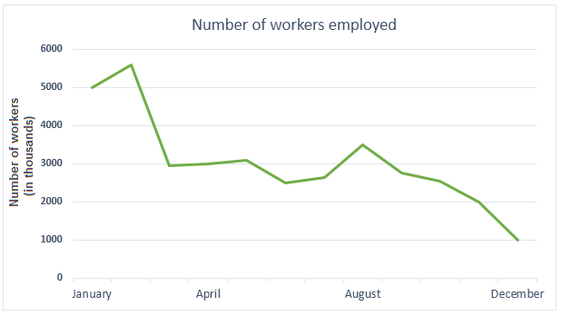

The line graphs provide information about production and demand for steel and number of workers in steel factories in the UK in 2010.

The overall amount of steal production is more than supply, until the last month of the year. The performance of steel has two peaks between January and April and in August. It was almost 5000 million tonnes. And the supplying had more peaks in this year, the top was around 3000 million tonnes. A more detailed look at the graph reveals that each trends extremely declined, since august. But after this fall, the demand mount starts growth, while production is still dipping.

On the other graph, the overall trend of workers for steel declined and in the December it was around 1000 millions tonnes. But it had have very good start with increasing of over 5000 million tonnes, and it was the biggest number of employees in 2010.

Clearly, the production of steel in 2010 were around 4000 million tonnes, but in august started to fall. In the opposite side, demand was near 2000 thones, but in December, after big declined, sharply growth. Nevertheless, the number of workers variation dip in this year.